SENTENCES WITH REDUCED CLAUSES
Dalam Bahasa inggris clause dapat hadir dalam bentuk yang lengkap ataupun reduced. Contoh :
- My friend should be on the train which is arriving at the station now
- My friend should be on the train arriving at the station now
- Although it was not really difficult, the exam took a lot of time
- Although not really difficult, the exam took a lot of time
Dua kalimat pertama menunjukan adjective clause yang di reduced, sedangkan dua kalimat terakhir menunjukan adverb clause yang di reduced.

SKILL 13 : USE ADJECTIVE CLAUSES CORRECTLY
Dalam bentuk reduced, connector dari adjective clause dan be yang mengikutinya dihilangkan. Contoh :
- The woman who is waving to us is the tour guide
- The woman waving to us is the tour guide
- The letter which was written last week arrived today
- The letter written last week arrived today
Apabila tidak ada be didalam adjective clause tersebut maka connector dihilangkan dan verb ditambahkan -ing. Contoh :
- I don’t understand the article which appears in today’s paper
- I don’t understand the article appearing in today’s paper
Apabila adjective clause di antarai oleh {,} maka perubahannya sbb :
- The white house, which is located in Washington, is the home of the president
- Located in Washington, the white house is the home of the president
- The president, who is now preparing to give a speech, is meeting with his advisors
- Now preparing to give a speech, the president is meeting with his advisors
INGAT!! Apabila connetornya tidak menjadi subject dari adjevtive clause tersebut, maka clause tersebut tidak boleh di reduced. Contoh :
- The woman that I just met is the tour guide
- The letter which you sent me arrived yesterday
Exercise
- We will have to return the merchandise purchased yesterday at the Broadway
- Correct
- Incorrect
- The children sat in the fancy restaurant found it difficult to behave
- Correct
- Incorrect
- Serving a term of four years, the mayor of the town will face re-election next year
- Correct
- Incorrect
- The brand new Cadillac, purchasing less than two weeks ago, was destroyed in the accident
- Correct
- Incorrect
- The fans who supporting their team always come out to the games in large numbers
- Correct
- Incorrect

SKILL 14 : USE REDUCED ADVERB CLAUSES CORRECTLY
Adverb clause juga dapat di reduce. Ketika di reduced, connectorsnya tidak hilang, yang hilang hanya subject dan be. Contoh :
- Although he is rather unwell, the speaker will take part in the seminar
- Although rather unwell, the speaker will take part in the seminar
- When you are ready, you can begin your speech
- When ready, you can begin your speech
Apabila clause itu menggunakan subject dan verb, maka subject dihilangkan dan verb ditambahkan -ing. Contoh :
- Although he feels rather sick, the speaker will take part in the seminar
- Although feeling rather sick, the speaker will take part in the seminar
- When you give your speech, you should speak loudly and distinctly
- When giving your speech, you should speak loudly and distinctly
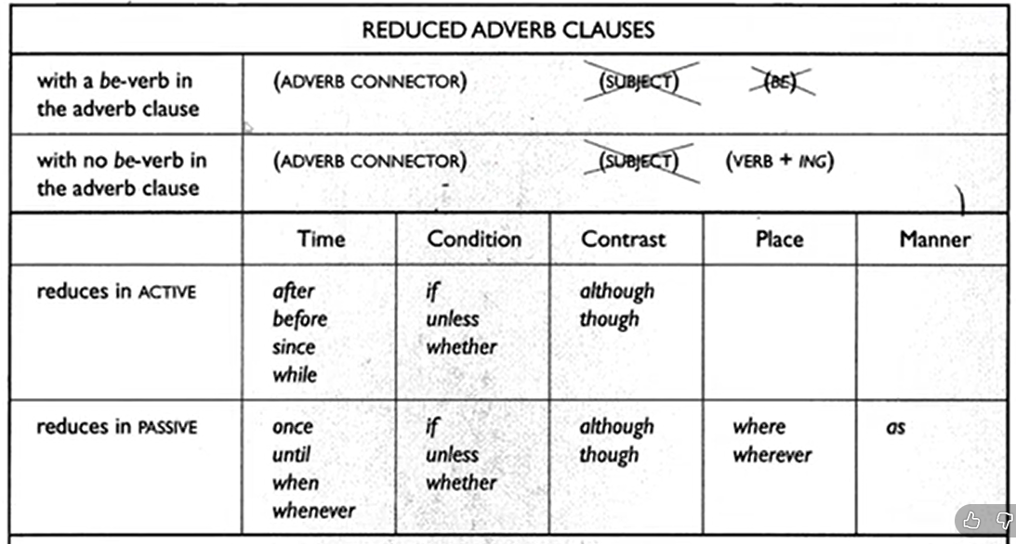
Untuk beberapa adverb connector diatas hanya bisa di reduced dalam bentuk passive. Contoh :
- Once you submit your thesis, you will graduate (tidak bisa reduce karena aktif)
- Once it is submitted, your thesis will be reviewed (bisa di reduce karena pasif)
- Once submitted, your thesis will be reviewed
Exercise
- If not completely satisfied, you can return the product to the manufacturer
- Correct
- Incorrect
- Steve has had to learn how to cook and clean since left home
- Correct
- Incorrect
- The ointment can be applied where needed
- Correct
- Incorrect
- Tom began to look for a job after completing his master’s degree in engineering
- Correct
- Incorrect
- Although not selecting for the team, he attends all of the games as a fan
- Correct
- Incorrect

EVALUASI SKILL 13 DAN 14
- Choose ‘correct’ or ‘incorrect’ for the following sentences
- The suspect can be seen in the photographs were just released by the police
- Correct
- Incorrect
- The food placing on the picnic table attracted a large number of flies
- Correct
- Incorrect
- Impressed with everything she had heard about the course, Marie signed her children up for it
- Correct
- Incorrect
- The passengers in the airport waiting room, heard the announcement of the cancelled flight, groaned audibly
- Correct
- Incorrect
- Dissatisfied with the service at the restaurant, the meal really was not really enjoyable
- Correct
- Incorrect
- When purchased at this store, the buyer gets a guarantee on all items
- Correct
- Incorrect
- The medicine is not effective unless taken as directed
- Correct
- Incorrect
- You should negotiate a lot before buy a new car
- Correct
- Incorrect
- Once purchased, the swimsuits cannot be returned
- Correct
- Incorrect
- Though located near the coast, the town does not get much of an ocean breeze
- Correct
- Incorrect

- Choose A, B, C, dan D for the correct answer
- When ___ nests during spring nesting season, Canadian geese are fiercely territorial
- Building
- Are building
- Built
- Are built
- In 1870, Calvin, along with Adirondack hunter Alvah Dunning, made the first known ascent of Seward Mountain, ____ far from roads or trails.
- A remote peak
- It is a remote peak
- A remote peak is
- Which a remote peak
- Kokanee Salmon begin to deteriorated and die soon ___ at the age of four.
- They spawn
- After spawning
- Spawn
- Spawned the salmon
- ___ behind government secrecy for nearly half a century, the Hanford plant in central Washington produced plutonium for the nuclear weapons of the cold war.
- It is hidden
- Hidden
- Which is hidden
- The plant is hiding
- Until ___ incorrect, astronomers had assumed that the insides of white dwarfs were uniform
- They
- Their proof
- The astronomers recently proven
- Recently proven
- ___ artifacts from the early Chinese dynasties, numerous archaeologists have explored the southern Silk Road.
- They were searching for
- It was a search for
- Searched for
- Searching for
- In Hailey, the best-known lecturer was women’s right activist Abigail Scott Duniway of Portland, Oregon, who could usually be persuaded to speak ___ town visiting her son.
- She was in
- While in’
- While she was
- Was in
- The National Restaurant ___ Washington, says that federal efforts to regulate workplace smoking would limit restaurants’ ability to respond to the desires of their patrons.
- Association in
- Association is in
- Association which is in
- Association, based in
- ___ in North American waterways a little over a decade ago, zebra mussels have already earned a nasty reputation for their expensive habit of clogging water pipes in the Great Lakes area.
- The first sighting
- Although first sighted
- Zebra mussels were first sighted
- First sighting
- Small companies may take their goods abroad for trade shows without paying foreign value added taxes by acquiring ___ an ATA carnet.
- A document calls
- A document called
- Calls a document
- Called a document

